

**Signals Project**

**Presented for ELC2030 Project**

**Presented to:**

**Dr. Michael Melek  
T.A: Alaa Khairalla**

|  |  |
| --- | --- |
| TEAM MEMBERS  (2nd Year Electronics and Electrical Communication Engineers) | |
| Magdy Ahmed Abbas Abdelhamid | **Section: 3 / I.D: 9210899** |



**Image Compression**

Task 1

**Explanation**

* (a): first: we read the image file (“image1.bmp”) using “imread” function.

then we print the image using “imshow” function as shown in Fig. (a.1).

second: we use the function “imsplit” to extract the three components of the image which are RGB components, then we display them in grayscale & RGB Scale using “imshow” as shown in from Fig. (a.2) to Fig (a.7) & each of them is labeled by its name using “title” function.

* (b): **first:** we define 2 functions one is DCT & the other is inverse DCT to call them when needed.

**second:** we decompose each color component image into 8x8 blocks using “blockproc” function which at the same time it applies the above defined DCT function to each 8x8 block of each of the 3 components then store the coefficients of the basis images in matrices called R_DCT, G_DCT, B_DCT.   
(Each 8x8 block of them will have 64 coefficients)

**third:** we define a temporary matrix of zeros of size (m x m) called “mask” which we add to it ones at specific positions at the top left according to the value of m, then we multiply it by the DCT coefficients of needed size at different values of $m= 1,2,3,4$ using a function called temporary & repeat this with each 8x8 block of each of the 3 components then store the result in matrices called R_NEW, G_NEW , B_NEW (each 8x8 block of them will contain coefficient matrix of size m x m in the top left of each block & the other cells outside size m x m will be zero) As Shown in Fig (b & c.8) to Fig (b & c.11).

* (c): As Shown in Fig (b & c.8) to Fig (b & c.11).  
  Size of Compressed Image at $m=1$ is 8 times smaller than the original image size.

Size of Compressed Image at $m=2$ is 4 times smaller than the original image size.

Size of Compressed Image at $m=3$ is $\frac{3}{8}$ times smaller than the original image size.

Size of Compressed Image at $m=4$ is 2 times smaller than the original image size.

* (d): **first:** to return to the original image we apply inverse DCT function on each 8x8 block of the matrices containing the coefficients which are R_NEW, G_NEW , B_NEW & store the result in R_INV, G_INV , B_INV , then we concatenate them using function “cat” and store the result in matrix called “decompression” which will contain the approximate 8x8 blocks of the original image at different values of m.

**second:** we display the compressed image at $m = 1,2,3,4$ as shown in Fig (b & c.8) to Fig (b & c.11) & display the decompressed image at $m = 1,2,3,4$ as shown in  
Fig (d & c.12) to Fig (d & c.15).

* (e): to get PSNR we need first to calculate Mean square error (MSE) between the original image and the decompressed image which is obtained by subtracting the corresponding pixel values of two images and obtaining the average of the square of all the differences (the peak value is considered to be 255)
* (f): we plot the PSNR graph for each value of m as shown in Fig (e & f.16) &   
  Fig (e & f.17) we notice that PSNR value increase with increasing value of m which means that the quality of image becomes better as m increase since we take greater number of DCT coefficients.
* Content In ZIP File in Task 1 (Image Compression): -
* Figures: In this Folder you Will Find Figures From (Fig 1) to (Fig 17).
* MATLAB.m Codes:   
  In this Folder you Will Find .m file ($image_compression.m$)
* Content of This File Respectively:
* One uncompressed pdf project report containing:   
  a. Explanation of your work.   
  b. All the required results and answers to questions.   
  c. All the required figures. Label your figures properly.   
  d. All the codes, included at the end.

**Questions & Answers**

(a): Read the image file ‘image1.bmp’.   
Extract and display each one of its three-color components.   
(Gray and RGB) Scales  
Ans: -

* Plotting: As Shown in from Fig. (a.2) to Fig (a.7)

(b): Compress the image by applying 2D DCT to each block.   
 at $m=1, 2, 3, 4$ and knowing its Sizes.  
Ans: -

* Plotting: As Shown in from Fig (b & c.8) to Fig (b & c.11).

(c): Compare the size of the original and compressed images.

Ans: -

* Sizes: As Shown in from Fig (b & c.8) to Fig (b & c.11).

(d): Decompress the image by applying Inverse 2D DCT to each block.   
 at $m=1, 2, 3, 4$ and knowing its Sizes.

Ans: -

* Plotting: As Shown in from Fig (d & c.12) to Fig (d & c.15).

(e): Obtain the PSNR for each value of m.

Ans: - As Shown in from Fig (e & f.16) to Fig (e & f.17).

|  |  |  |  |  |
| --- | --- | --- | --- | --- |
| m | 1 | 2 | 3 | 4 |
| PSNR | $$19.8635$$ | $$21.9069$$ | $$23.7734$$ | $$25.9427$$ |

(f): Plot a curve displaying the PSNR (on the vertical axis) against m (on the horizontal axis). Comment on the resulting graph and quality of images.

Ans: -

* As DCT coefficients increase, the quality of the image gets better. hence the PSNR value was expected to increase

The higher the PSNR, the better the quality of the compressed,   
or reconstructed image.

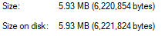

**Figures & Labels**

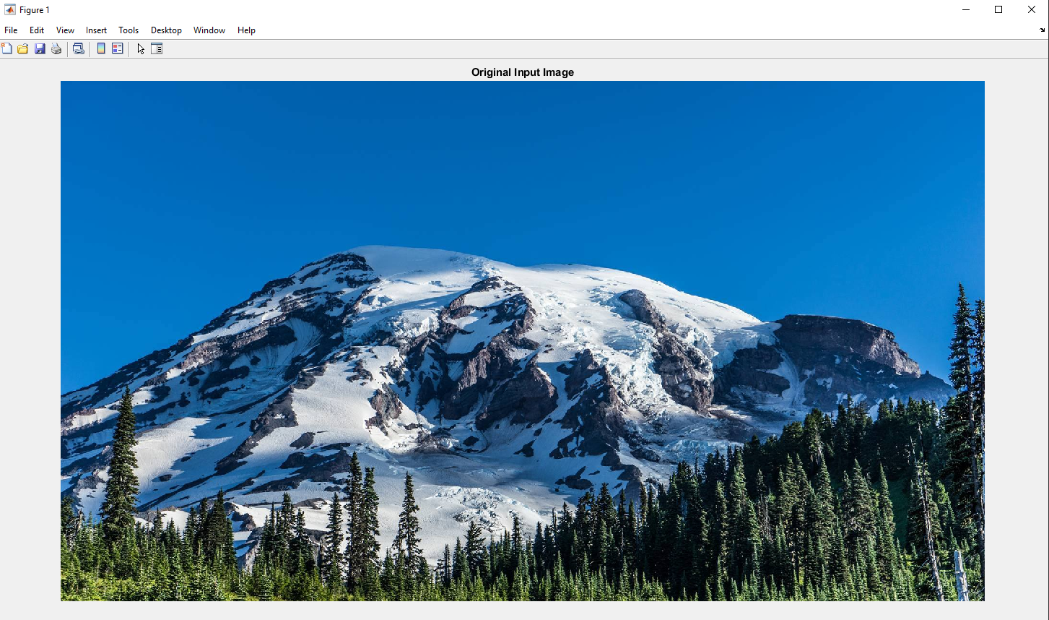

Fig (a & c.1): Orignal Image & its Size

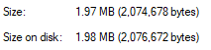

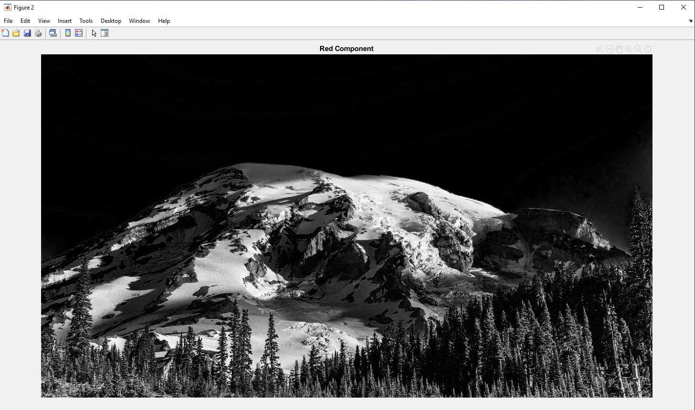

Fig (a.2): Red Component Image in Gray Scale

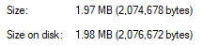

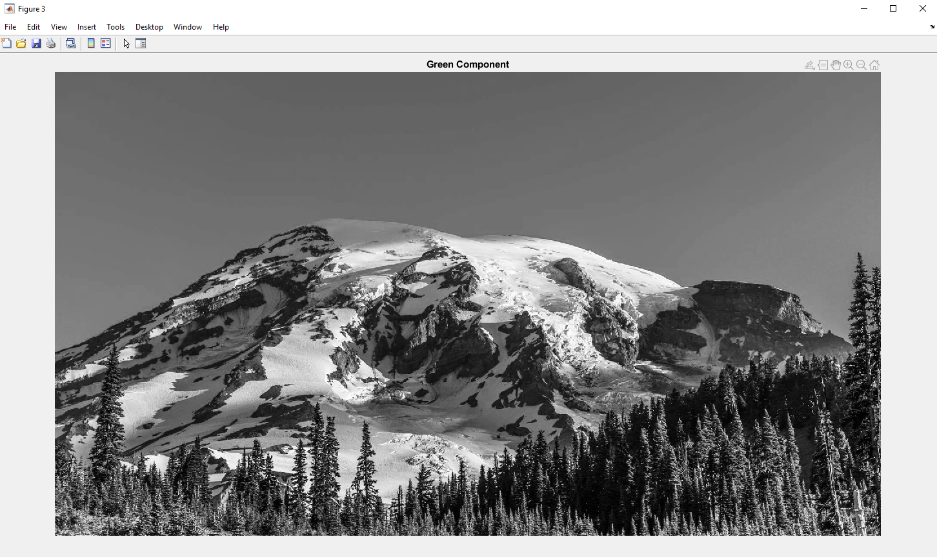

Fig (a.3): Green Component Image in Gray Scale

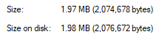

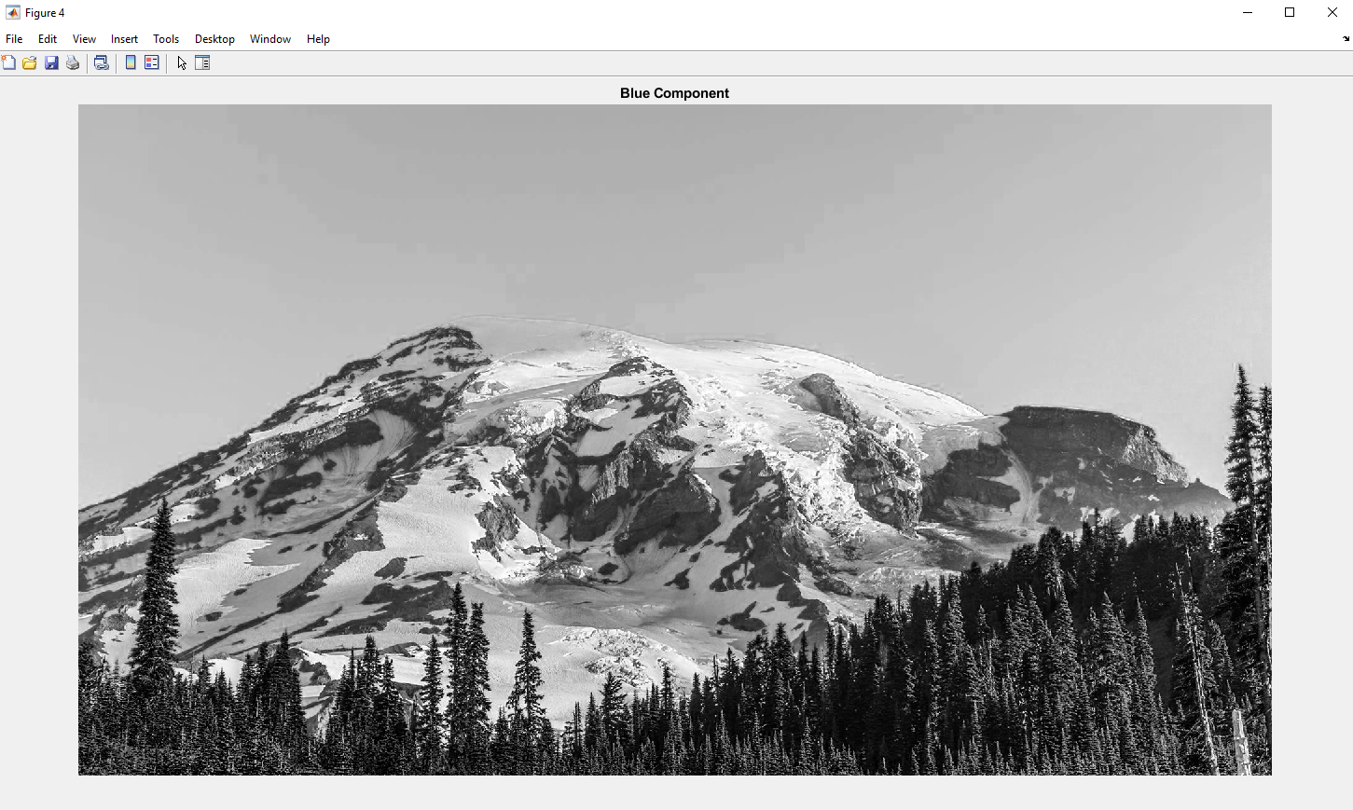

Fig (a.4): Blue Component Image in Gray Scale

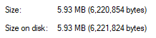

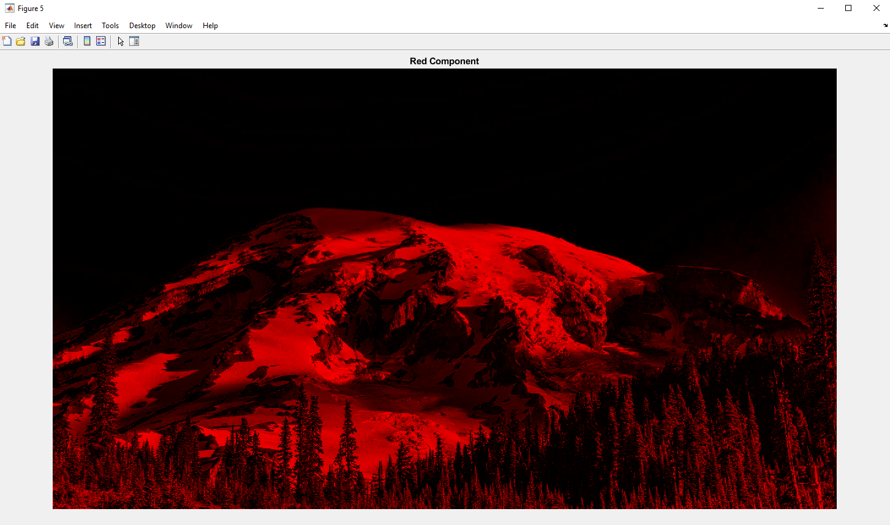

Fig (a.5): Red Component Image in RGB Scale

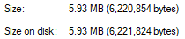

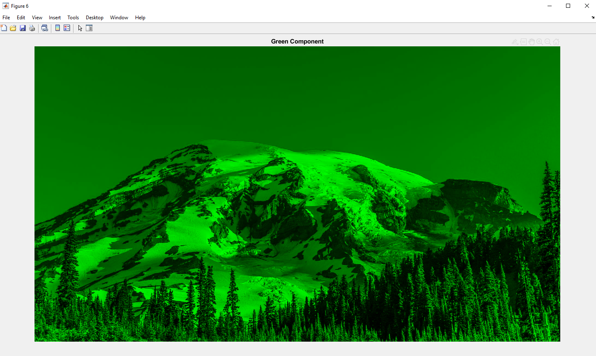

Fig (a.6): Green Component Image in RGB Scale

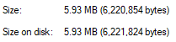

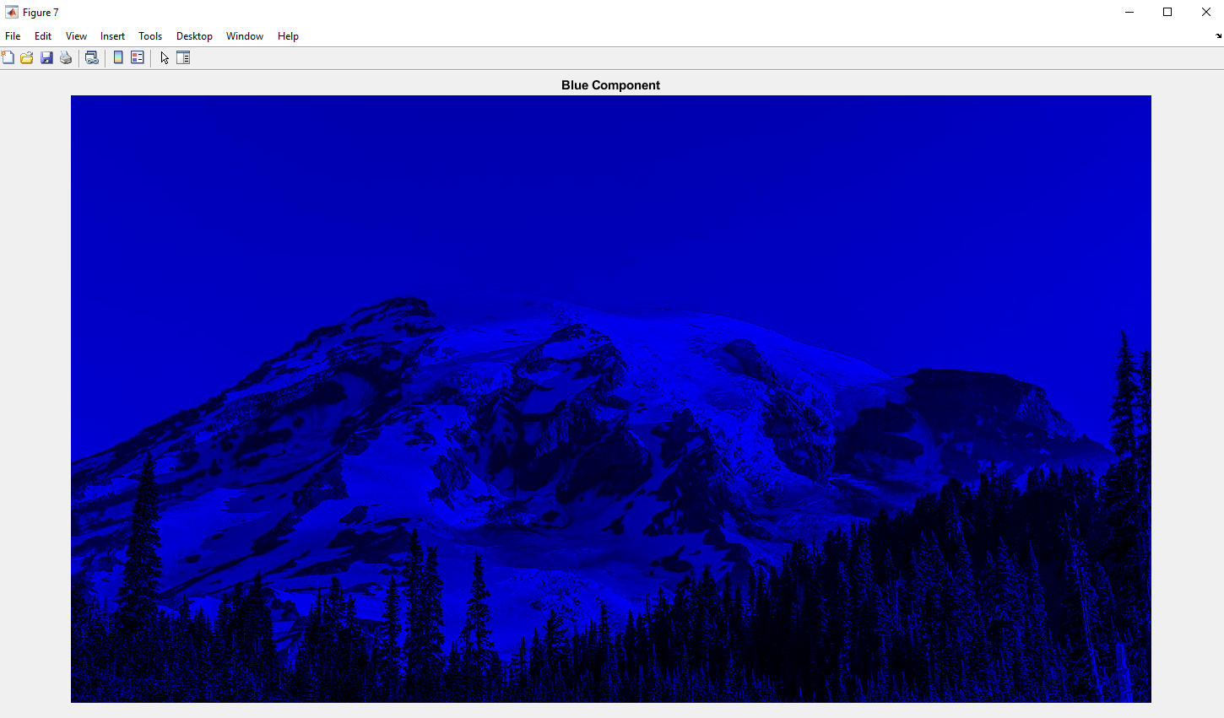

Fig (a.7): Blue Component Image in RGB Scale

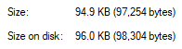

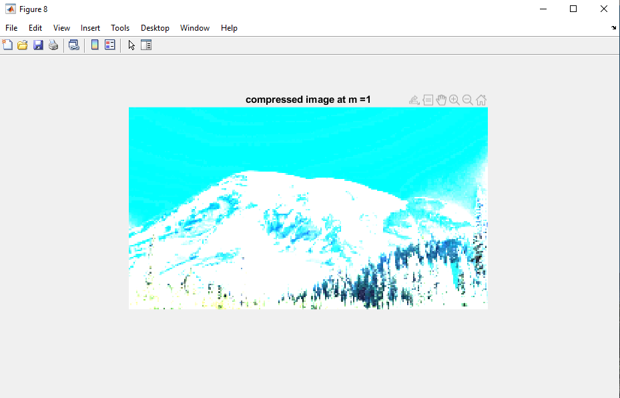

Fig (b & c.8): Compressed Image at $m=1$& its Size

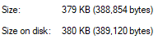

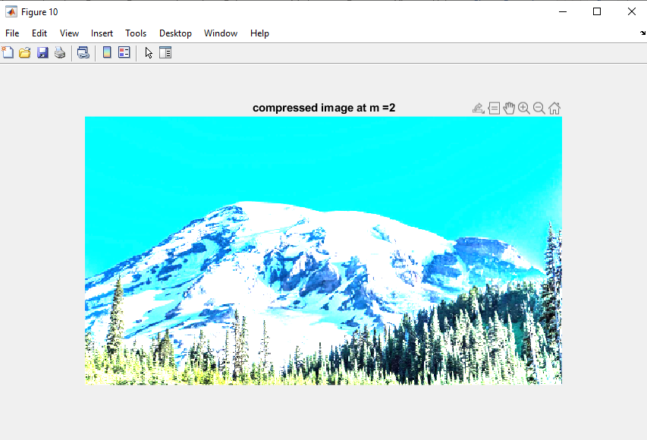

Fig (b & c.9): Compressed Image at $m=2$& its Size

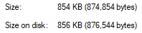

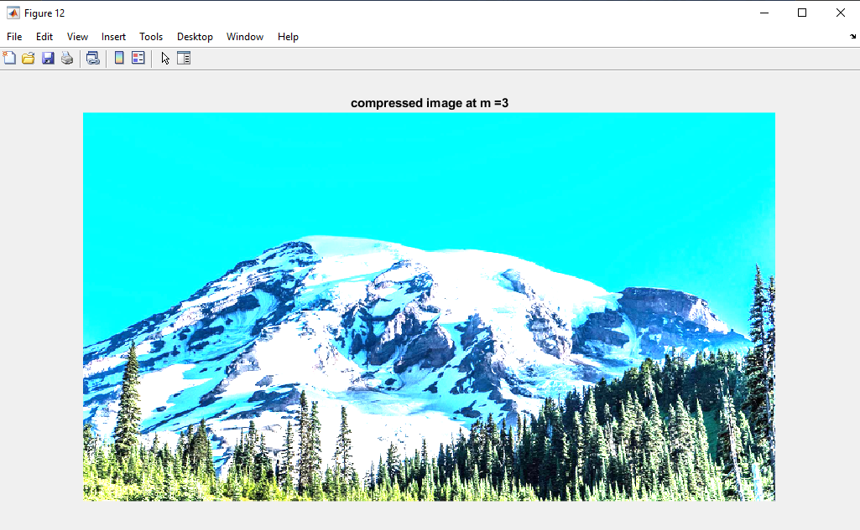

Fig (b & c.10): Compressed Image at $m=3$& its Size

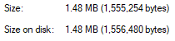

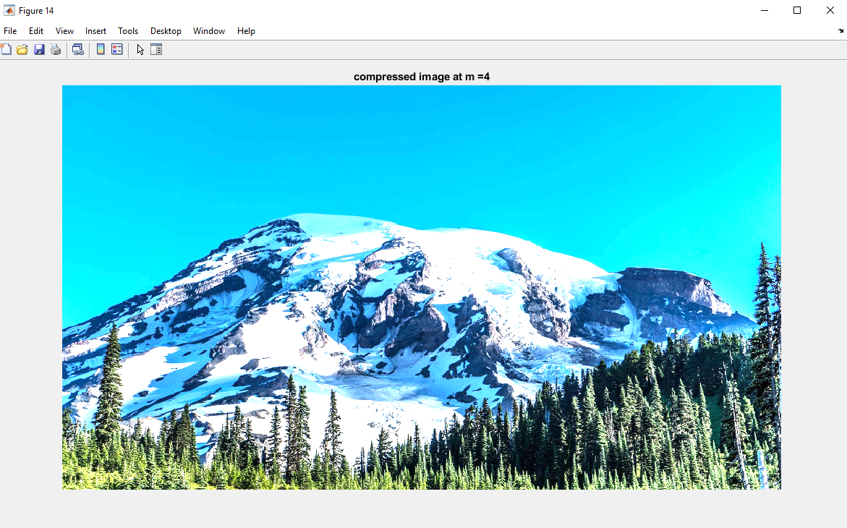

Fig (b & c.11): Compressed Image at $m=4$& its Size

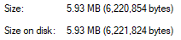

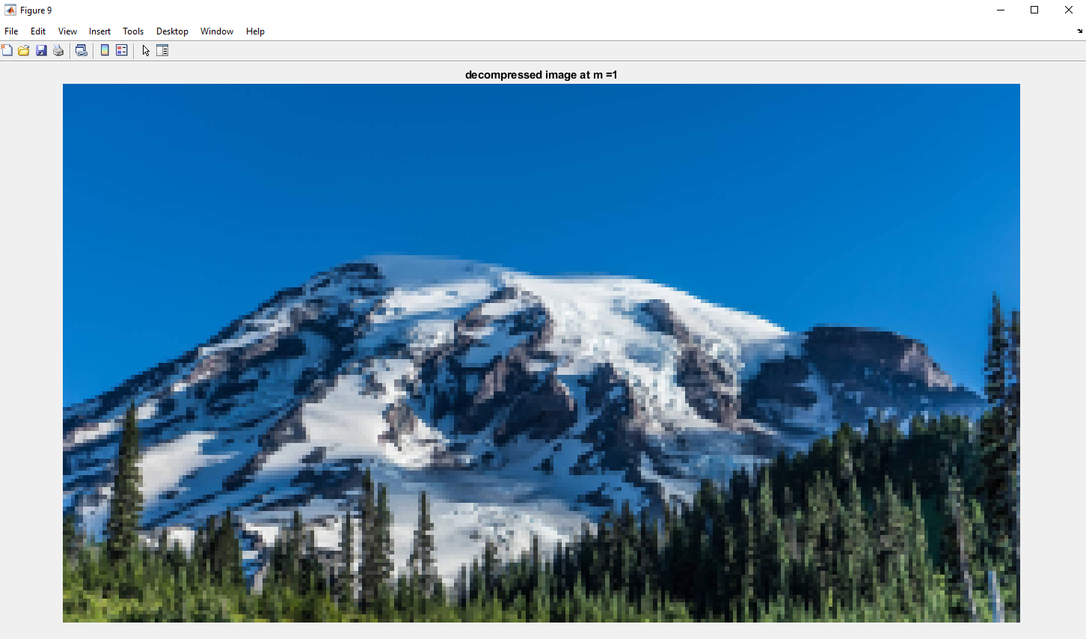

Fig (d & c.12): Decompressed Image at $m=1$& its Size



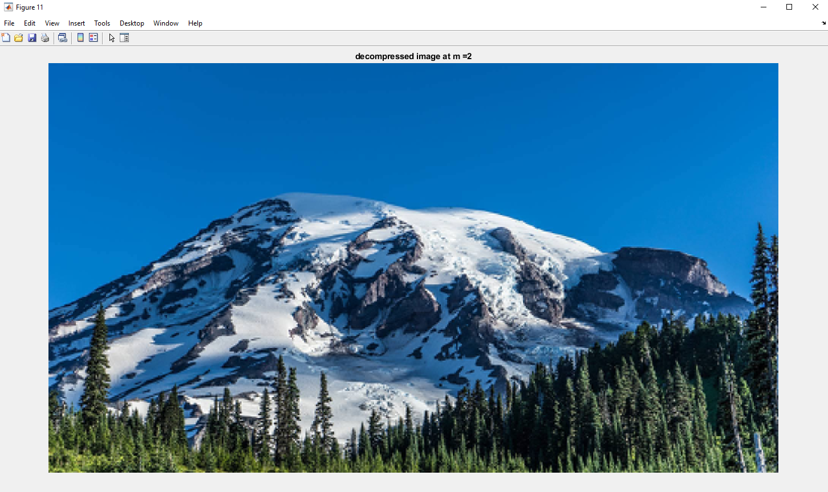

Fig (d & c.13): Decompressed Image at $m=2$& its Size



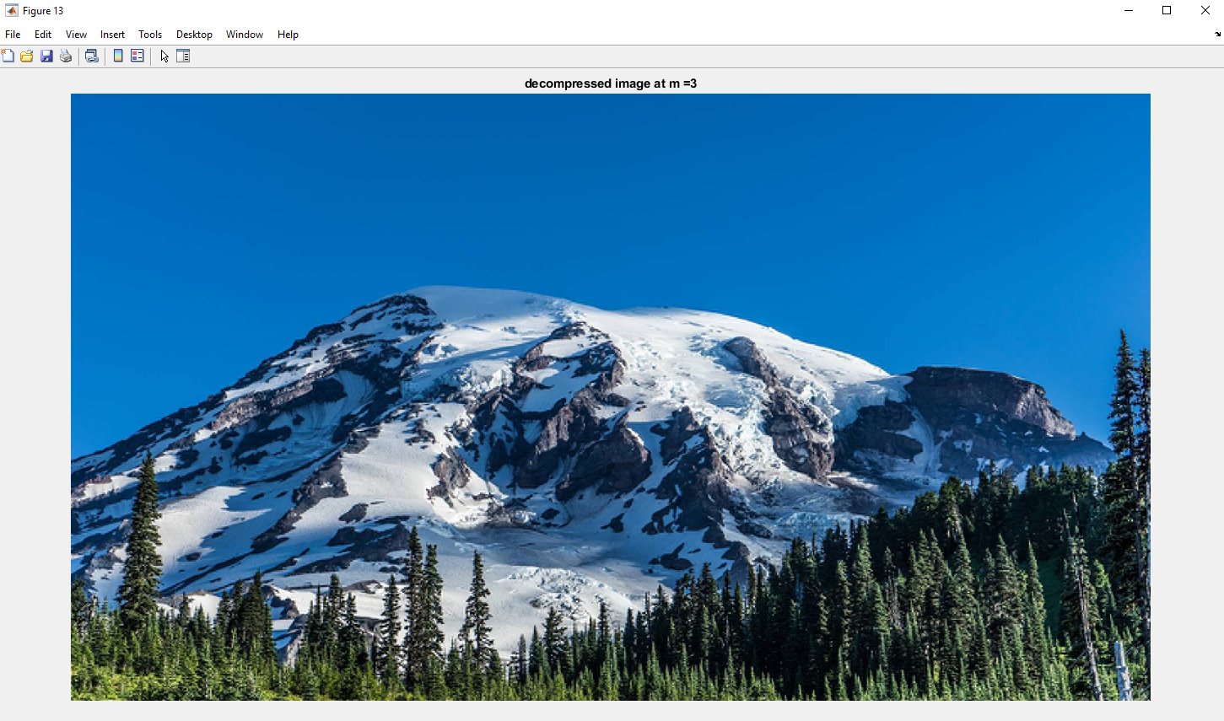

Fig (d & c.14): Decompressed Image at $m=3$& its Size



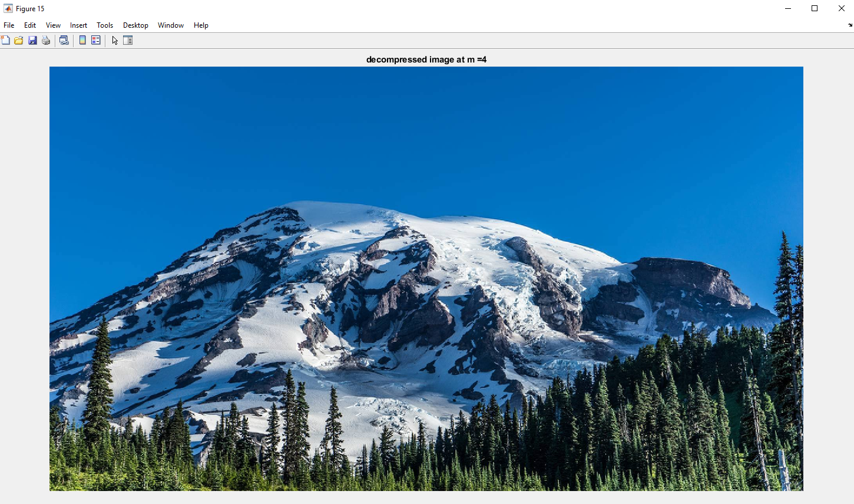

Fig (d & c.15): Decompressed Image at $m=4$& its Size

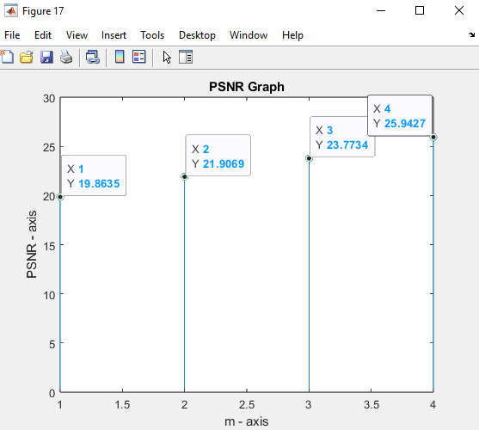

Fig (e & f.16): PSNR Graph in Discrete Values

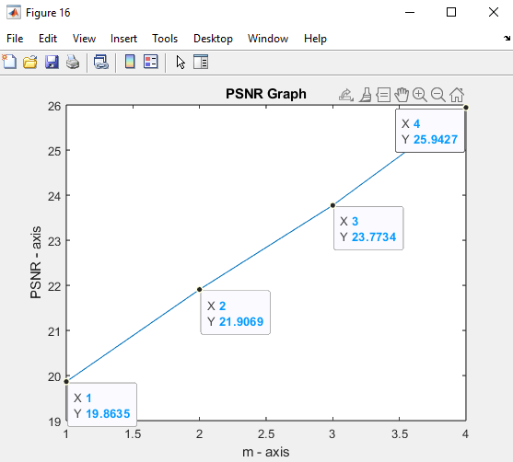

Fig (e & f.17): PSNR Graph at $m=1, 2, 3, 4$

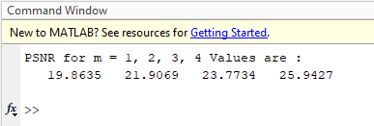

**MATLAB Codes**

$$\%\% Task (a)$$

$$clc$$

$$close all;$$

$$\% Read and display The image input file using Relative Path.$$

$$Input_image = imread('image1.bmp');$$

$$[l,w] = size(Input_image(:,:,1));$$

$$figure, imshow(Input_image);$$

$$title("Original Input Image")$$

$$\% Extract and display each one of its three color components.$$

$$[R_component,G_component,B_component] = imsplit(Input_image);$$

$$black = zeros(l,w);$$

$$\% In Gray Scale$$

$$figure$$

$$imshow(R_component);$$

$$title('Red Component');$$

$$imwrite(R_component, 'Red Component.bmp');$$

$$figure$$

$$imshow(G_component);$$

$$title('Green Component');$$

$$imwrite(G_component, 'Green Component.bmp');$$

$$figure$$

$$imshow(B_component);$$

$$title('Blue Component');$$

$$imwrite(B_component, 'Blue Component.bmp');$$

$$\% In RGB Scale$$

$$red = cat(3,R_component,black,black);$$

$$green = cat(3,black,G_component,black);$$

$$blue = cat(3,black,black,B_component);$$

$$figure$$

$$imshow(red)$$

$$imwrite(red,'Red Component RGB.bmp');$$

$$title('Red Component');$$

$$figure$$

$$imshow(green);$$

$$imwrite(green,'Green Component RGB.bmp');$$

$$title('Green Component');$$

$$figure$$

$$imshow(blue);$$

$$imwrite(blue,'Blue Component RGB.bmp');$$

$$title('Blue Component');$$

$$\%\% Applying DCT \& Inverse DCT to 8*8 Blocks$$

$$\% Task (b) \& (c) \& (d) Repeat for m = 1,2,3,4:$$

$$\% compress the image, process each color component in blocks of 8 × 8 pixels.$$

$$\% Each block will be converted into frequency domain using 2D DCT.$$

$$\% then only few coefficients are retained, while the rest will be ignored.$$

$$\% Apply 2D DCT of each block having the same dimensions as the input block$$

$$decompression = cell(1,4);$$

$$compression = cell(1,4);$$

$$get_dct2 = @(block_struct) dct2(block_struct.data);$$

$$get_invdct2 = @(block_struct) idct2(block_struct.data);$$

$$mask = zeros(8);$$

$$R_DCT = blockproc(R_component,[8 8],get_dct2);$$

$$G_DCT = blockproc(G_component,[8 8],get_dct2);$$

$$B_DCT = blockproc(B_component,[8 8],get_dct2);$$

$$for m = 1:4$$

$$mask(1:m,1:m) = 1;$$

$$temporary = @(block_struct) block_struct.data.*mask;$$

$$\% Control the DCT Coefficient Outputs$$

$$R_NEW = blockproc(R_DCT,[8 8],temporary);$$

$$G_NEW = blockproc(G_DCT,[8 8],temporary);$$

$$B_NEW = blockproc(B_DCT,[8 8],temporary);$$

$$temp = @(block_struct) block_struct.data(1:m,1:m);$$

$$R_compressed = blockproc(R_DCT,[8 8],temp);$$

$$G_compressed = blockproc(G_DCT,[8 8],temp);$$

$$B_compressed = blockproc(B_DCT,[8 8],temp);$$

$$R_compressed_INVDCT = blockproc(R_compressed,[m m],get_invdct2);$$

$$G_compressed_INVDCT = blockproc(G_compressed,[m m],get_invdct2);$$

$$B_compressed_INVDCT = blockproc(B_compressed,[m m],get_invdct2);$$

$$compressed_image = uint8(cat(3,R_compressed_INVDCT,G_compressed_INVDCT,B_compressed_INVDCT));$$

$$compression\{1,m\} = compressed_image;$$

$$R_INVDCT = blockproc(R_NEW,[8 8],get_invdct2);$$

$$G_INVDCT = blockproc(G_NEW,[8 8],get_invdct2);$$

$$B_INVDCT = blockproc(B_NEW,[8 8],get_invdct2);$$

$$decompression\{1,m\} = uint8(cat(3,R_INVDCT,G_INVDCT,B_INVDCT));$$

$$end$$

$$\%\% Task (e) \& Task (f) Calculation and Plotting PSNR (Peak signal - to Noise Ratio)$$

$$peaksnr = ones(1,4);$$

$$Remaining = 0;$$

$$for m = 1:4$$

$$imwrite(compression\{1,m\},strcat('compressed image at m = ', num2str(m),'.bmp'));$$

$$imwrite(decompression\{1,m\},strcat('decompressed image at m = ', num2str(m),'.bmp'));$$

$$figure$$

$$imshow(compression\{1,m\})$$

$$title(strcat('compressed image at m = ', num2str(m)));$$

$$figure$$

$$imshow(decompression\{1,m\})$$

$$title(strcat('decompressed image at m = ', num2str(m)));$$

$$peaksnr(m) = psnr(uint8(decompression\{1,m\}),uint8(Input_image));$$

$$end$$

$$fprintf("PSNR for m = 1, 2, 3, 4 Values are : \backslash n");$$

$$disp(peaksnr);$$

$$figure$$

$$plot(1:4,peaksnr)$$

$$title('PSNR Graph')$$

$$xlabel('m - axis')$$

$$ylabel('PSNR - axis')$$

$$figure$$

$$stem(1:4,peaksnr)$$

$$title('PSNR Graph')$$

$$xlabel('m - axis')$$

$ylabel('PSNR - axis')$

**Audio Spectral Analysis And Filtering**

Task 2

**Explanation**

* Q (a): By Using $test_noisy_audio.m$ MATLAB File To get input information  
  as Shown in Fig (a.1) & Fig (a.2) we get that $F_{stop}=3000 HZ$ we Approximate it to $3000 HZ$ in filter Designer tool and $F_{pass}=2500 HZ$ Approximately or any number between $2000 HZ to 2700 HZ$ in filter Designer tool & Then we Know that the Interfering signal: High Frequency Sinusoidal (Cosine) Signal (In Time Domain).  
  Impulse Signal in (Freq. Domain).
* Q (b): As Shown in Fig (b.3) & Fig (b.4), In Response Type We use Lowpass Filter,  
  In Design Method We use IIR (Butterworth), and In Frequency Specifications in Hz units we take $F_{s}=48000 Hz, F_{pass}=2500 Hz, F_{stop}=3000 HZ,$ And then We Click Design Filter and then Export the Variables to the Workspace as an object as shown in Fig 0. In ZIP file.
* Q (c): By Using audio.m MATLAB File after Run it will Create A filtered Sound file of the Output audio Without noise (Interfering signal).
* Q (d): As Shown in Fig (d.5) & Fig (d.6), we find that the last sound signals around $3000 HZ$ then it is Filtered Successfully in filtered.wav.
* Q (e): As Shown in Fig (e.7) it’s the Magnitude (dB) of the Frequency Response & In Fig (e.8) it’s the Phase of the Frequency Response & Fig (e.9) it’s the Combination of the Magnitude (dB) & Phase of the Frequency Response all figures from $freqz(Hd)$.
* Q (f): As Shown in Fig (f.10) We get Impulse Response by typing $impz(Hd)$ in the terminal Shown in MATLAB.
* Q (h): By Using audiox2.m MATLAB File after Run it will Create filteredx2 Sound file of the Output audio Without noise (Interfering signal) but with Twice Speed and As Shown in Fig (h.11) & Fig (h.12) we find that the last sound signals around $4000 HZ$ then it is Filtered with Twice Speed Successfully in filteredx2.wav.
* Content In ZIP File in Task 2 (Audio Spectral Analysis & Filtering): -
* Figures: In this Folder you Will Find Figures From (Fig 0) to (Fig 12).
* Filtered Sounds: In this Folder you Will Find Audios  
  (Original & Filtered & Filteredx2).
* MATLAB.m Codes: In this Folder you Will Find .m files   
  (audio.m & audiox2.m & $test_noisy_audio.m$).
* Content of This File Respectively:
* One uncompressed pdf project report containing:   
  a. Explanation of your work.   
  b. All the required results and answers to questions.   
  c. All the required figures. Label your figures properly.   
  d. All the codes, included at the end.

**Questions & Answers**

Q (a): Use FFT to obtain the magnitude spectrum of the audio file “audio.wav”.   
Plot it against the frequency in Hz. Use the function ‘fftshift’ to make the zero frequency in the center of the plot? What is the type of the Interfering signal?

Ans: -

* Plotting: In Figures & Labels Section (Fig (a.1) & Fig (a.2)).
* The type of the Interfering signal:   
  High Freq. Sinusoidal (Cosine) Signal. (In Time Domain).

Impulse Signal. (In Frequency Domain).

Q (b): Use a suitable filter of your choice to remove the interfering signal.   
The filter choice should be based on the spectrum in part (a).   
(Moving average filter should not be used). Give all the filter specifications.

Ans: -

* Plotting: In Figures & Labels Section (Fig (b.3) & Fig (b.4)).
* Filter specifications: From Part (a) Put $F_{stop}≅3000 \& F_{pass}≅2500$ 
  Design Method (IIR Butterworth) & Response Type (Low pass).

Q (c): Play the filtered audio. (Record it as “filtered.wav”): 

Q (d): Plot the spectrum of the filtered audio.

Ans: -

* Plotting: In Figures & Labels Section (Fig (d.5) & Fig (d.6)).

Q (e): Plot the frequency response of the filter.

Ans: -

* Plotting: In Figures & Labels Section (Fig (e.7) & Fig (e.8) & Fig (e.9)).

Q (f): Plot the impulse response of the filter. What is the relationship between the impulse response and the frequency response in part (e)?

Ans: -

* Plotting: In Figures & Labels Section (Fig (f.10)).
* the relationship between the impulse response and the frequency response:  
  A system's frequency response $H\left( jω\right)$ is the Fourier Transform of its impulse response $h\left(t\right)$.

Q (g): Is the filter causal or not? Explain your answer.

Ans: -

* Yes, it is causal. Because $h\left(t\right)= 0$ for $t <0$  
  It had to be causal to be practical for a real-time application.

Q (h): Play the filtered audio at twice the speed. Plot the new spectrum.   
What do you notice on the spectrum compared to the spectrum of the normal speed file?

Ans: -

* Plotting: In Figures & Labels Section (Fig (h.11) & Fig (h.12)).
* Notice on the spectrum:   
  Expansion of the Frequency Range $\left(F_{s}\right)$ of the New Spectrum Approximately be Double the Normal Spectrum Frequency Range for the audio input file. the magnitude of the spectrum at Twice speed is the same as the magnitude of the normal speed from.

**Figures & Labels**

   
Q (a): Plot the magnitude spectrum of the original audio file against the frequency in Hz.

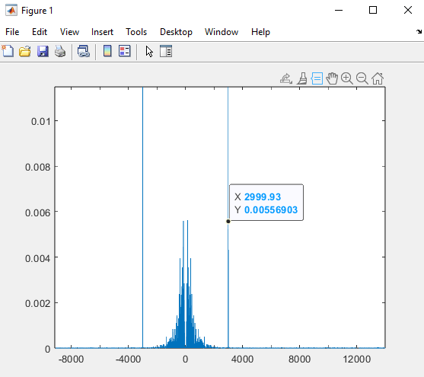

Fig (a.1): Input Audio Signal $F_{stop}≅3000 HZ$

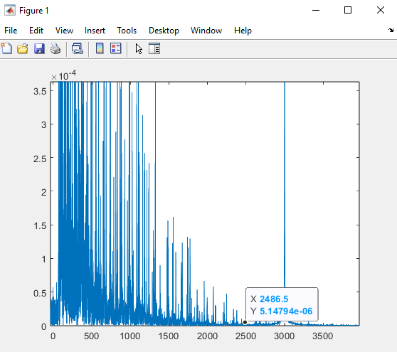

Fig (a.2): Input Audio Signal $F_{pass}≅2500 HZ$

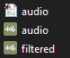

Q (b): Filter Design Magnitude & Magnitude (dB) against the frequency in Hz.

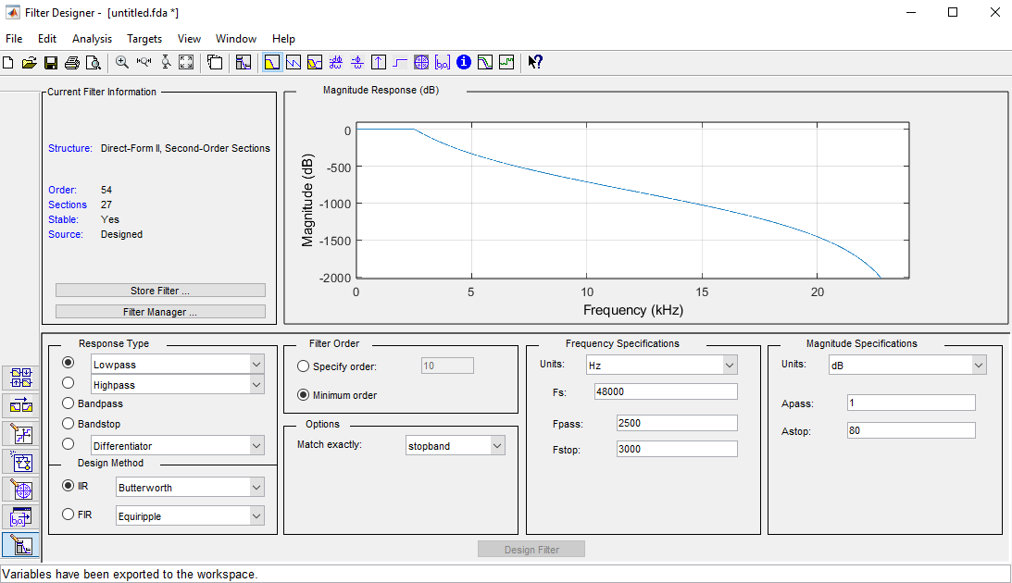

Fig (b.3): Filter Design (Magnitude (dB))

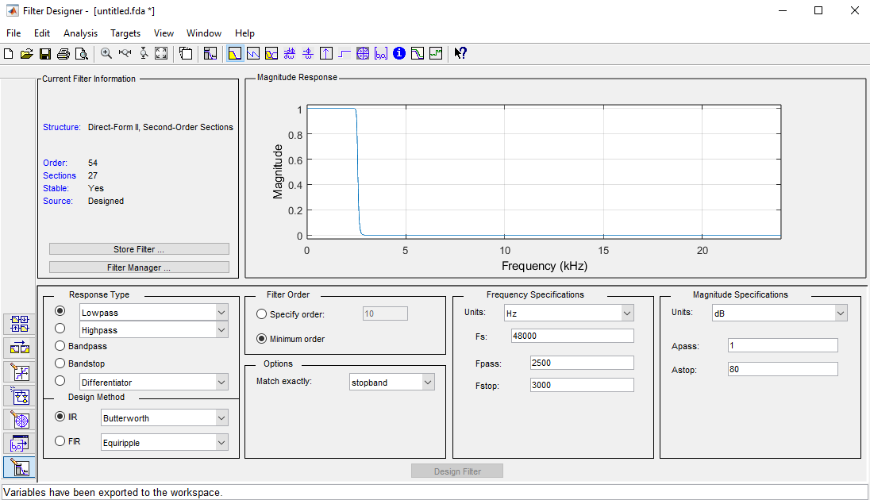

Fig (b.4): Filter Design (Magnitude)

Q (d): Plot the spectrum of the filtered audio.

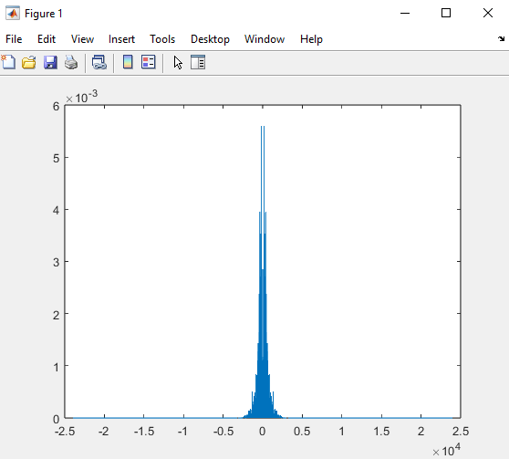

Fig (d.5): the spectrum of the filtered audio.

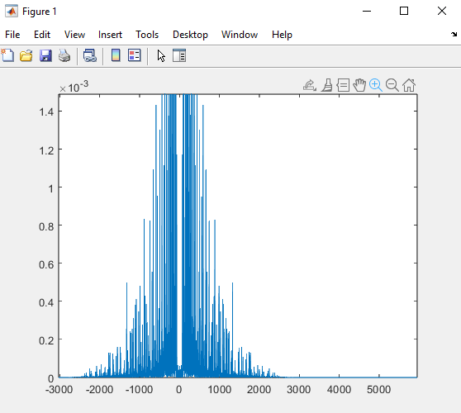

Fig (d.6): the spectrum of the filtered audio.

Q (e): Plot the spectrum of the filtered audio. (By typing freqz $\left(Hd\right)$ in MATLAB)

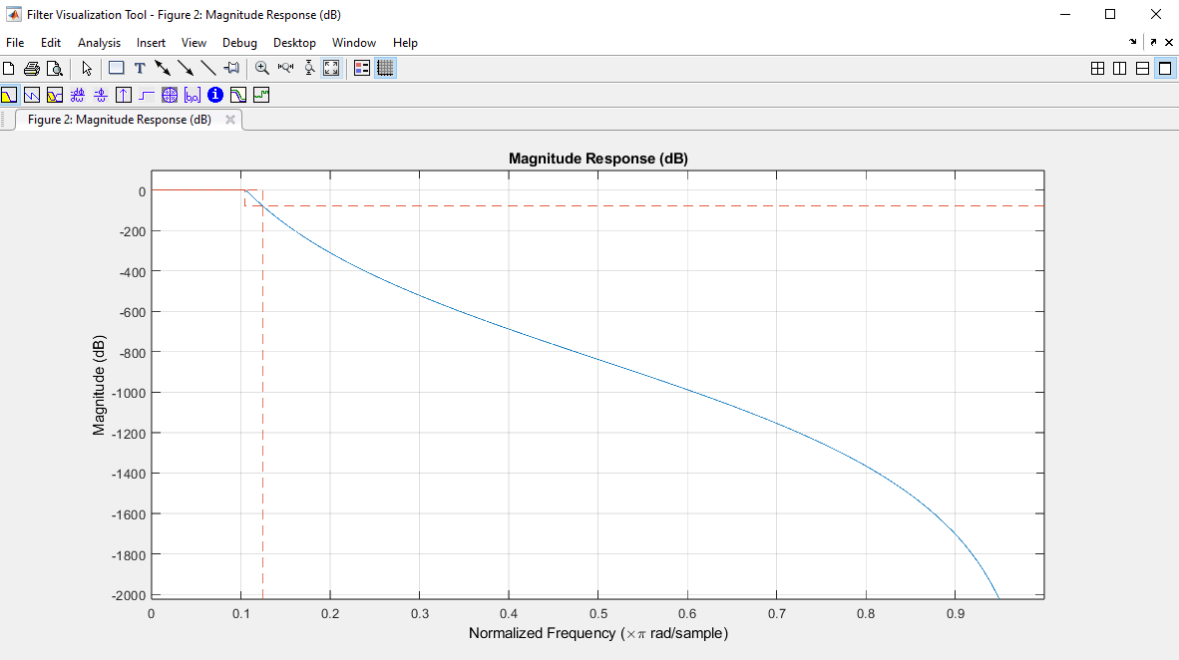

Fig (e.7): Frequency Response (Magnitude (dB))

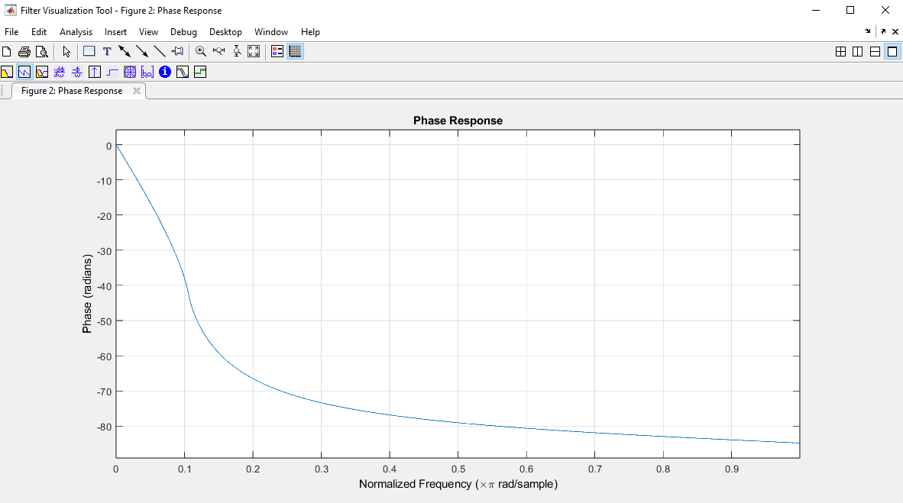

Fig (e.8): Frequency Response (Phase)

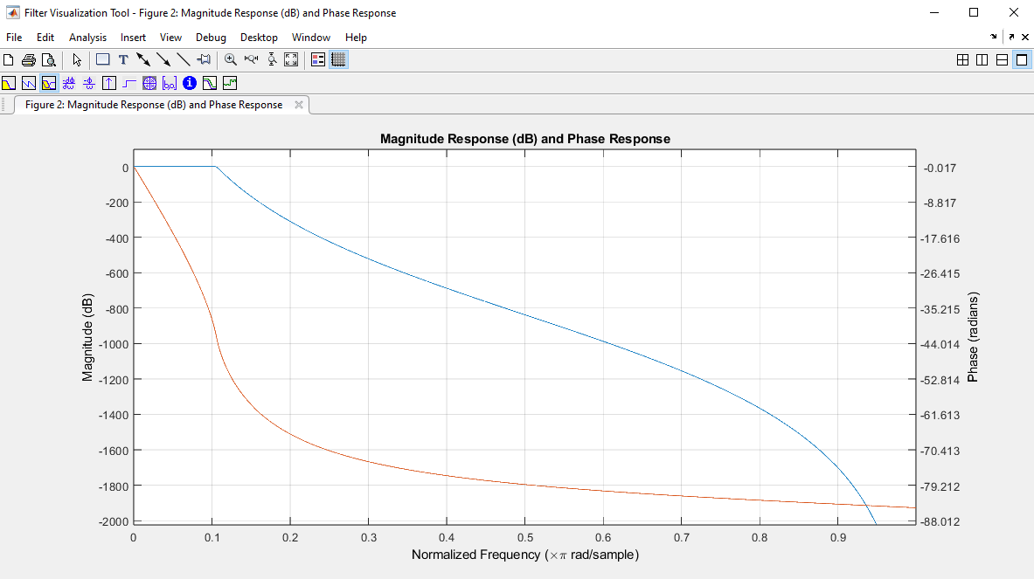

Fig (e.9): Frequency Response (Magnitude (dB)) & (Phase)

Q (f): Plot the impulse response of the filter. (By typing impz $\left(Hd\right)$ in MATLAB)

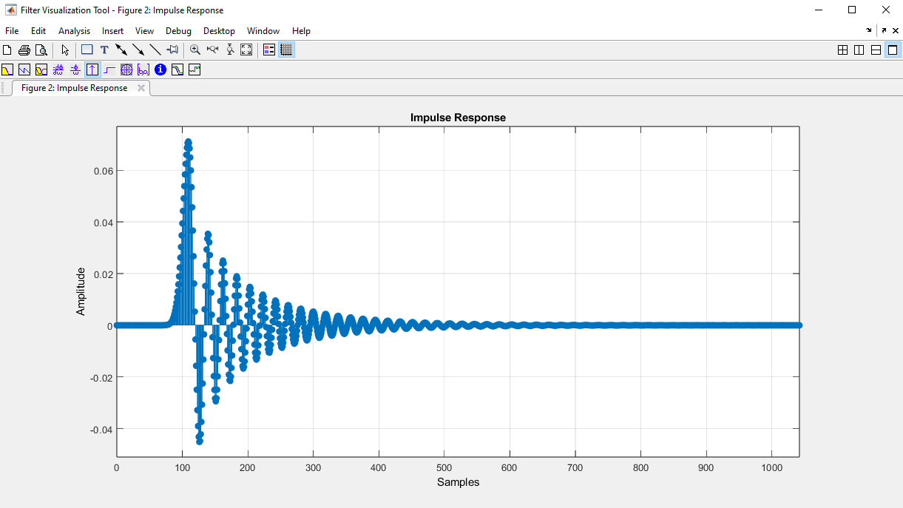

Fig (f.10): Impulse Response (Amplitude)

Q (h): Play the filtered audio at twice the speed. Plot the new spectrum.

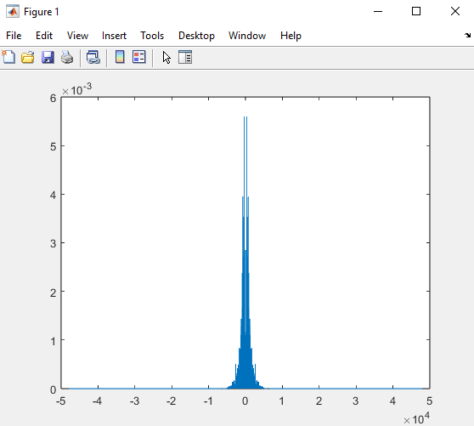

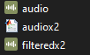

Fig (h.11): filtered audio at twice the speed

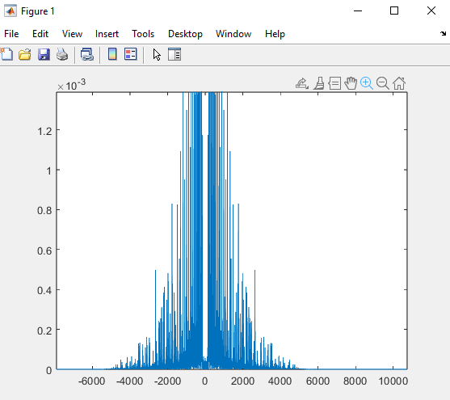

Fig (h.12): filtered audio at twice the speed (Double the Normal Frequency Range)

**MATLAB Codes**



 With Normal Speed.

$$\%\% Read The Input Audio$$

$$[x, fs] = audioread('audio.wav');$$

$$N = length(x);$$

$$\%\% Plotting against k$$

$$k = 0 : N - 1;$$

$$y = fft(x,N);$$

$$plot(k,abs(y));$$

$$\%\% Plotting against Frequency in HZ$$

$$f = (0 : N - 1) * fs / N;$$

$$plot(f, abs(y) / N);$$

$$\%\% Shifting Zero to the center of Spectrum$$

$$\% then Plotting against Frequency in HZ$$

$$f = (-N / 2 : N / 2 - 1) * fs / N;$$

$$plot(f, abs(fftshift(y)) / N);$$

$$\%\% Filtering With Fstop ≅ 3000 \& Fpass ≅ 2500$$

$$filtered = filter(Hd, x);$$

$$m = length(filtered);$$

$$Filtered_NEW = fft(filtered, m);$$

$$\%\% Plotting against k$$

$$plot(k, abs(Filtered_NEW));$$

$$\%\% Plotting against Frequency in HZ$$

$$f = (0 : N - 1) * fs / m;$$

$$plot(f,abs(Filtered_NEW) / m);$$

$$\%\% Shifting Zero to the center of Spectrum$$

$$f = (-N / 2 : N / 2 - 1) * fs / m;$$

$$\%\% Plotting against Frequency in HZ$$

$$plot(f, abs(fftshift(Filtered_NEW)) / m);$$

$$\%\% Write The Output Audio$$

$$audiowrite("filtered.wav", filtered, fs);$$

$$[z, fss] = audioread("filtered.wav");$$

$$sound(z, fss);$$

$$\%\% Plotting the Frequency Responce \& Impulse Response$$

$$impz(Hd);$$

$$freqz(Hd);$$

 With at Twice the Speed.

$$\%\% Read The Input Audio$$

$$[x, fs] = audioread('audio.wav');$$

$$N = length(x);$$

$$\%\% Plotting against k$$

$$k = 0 : N - 1;$$

$$y = fft(x,N);$$

$$plot(k,abs(y));$$

$$\%\% Plotting against Frequency in HZ$$

$$f = (0 : N - 1) * fs / N;$$

$$plot(f, abs(y) / N);$$

$$\%\% Shifting Zero to the center of Spectrum$$

$$\% then Plotting against Frequency in HZ$$

$$f = (-N / 2 : N / 2 - 1) * fs / N;$$

$$plot(f, abs(fftshift(y)) / N);$$

$$\%\% Filtering With Fstop ≅ 3000 \& Fpass ≅2500$$

$$filtered = filter(Hd, x);$$

$$m = length(filtered);$$

$$Filtered_NEW = fft(filtered, m);$$

$$\%\% Plotting against k$$

$$plot(k, abs(Filtered_NEW));$$

$$\%\% Plotting against Frequency in HZ x2 Speed$$

$$f = (0 : N - 1) * (2*fs) / m;$$

$$plot(f,abs(Filtered_NEW) / m);$$

$$\%\% Shifting Zero to the center of Spectrum$$

$$f = (-N / 2 : N / 2 - 1) * (2*fs) / m;$$

$$\%\% Plotting against Frequency in HZ$$

$$plot(f, abs(fftshift(Filtered_NEW)) / m);$$

$$\%\% Write The Output Audio x2 Speed$$

$$audiowrite("filteredx2.wav", filtered, 2*fs);$$

$$[z, fss] = audioread("filteredx2.wav");$$

$$sound(z, 2*fss);$$

$$\%\% Plotting the Frequency Responce \& Impulse Response$$

$$impz(Hd);$$

$$freqz(Hd);$$